**Amoxicillin and Doxycycline Five-day OptimiseRx best practice message**

NICE guidance recommends five-day courses when antibiotics are indicated for: sinusitis, sore throat, COPD infective exacerbation, acute cough, community acquired pneumonia and otitis media. Some indications require longer durations. Examples include acute exacerbations of bronchiectasis, treatment of H. Pylori & treatment of infected leg ulcers. NICE guidance can be accessed at [**NICE: antimicrobial prescribing guidance**](https://elearning.rcgp.org.uk/mod/book/view.php?id=14887)

The national OptimiseRx team are trialling five-day duration messages for Amoxicillin 500mg and Doxycycline 100mg to support the NICE guidance recommendations. During World Antimicrobial Resistance Awareness Week (WAAW), 18 -24 November, a five-day duration best practice message will be live on OptimiseRx for all practices across LSC. WAAW resources can be found at [**UKHSA: World AMR Awareness Week 2024**](https://www.gov.uk/government/publications/european-antibiotic-awareness-day-resources-toolkit-for-healthcare-professionals-in-england/world-antimicrobial-awareness-week-waaw-and-european-antibiotic-awareness-day-eaad)

* **Headline message for Amoxicillin 500mg capsules:** For most indications NICE recommends a five-day course of amoxicillin; prescribe the shortest effective course of treatment.​
* **Details behind the headline:** NICE guidance for common infections routinely recommends the shortest effective course of treatment, to reduce selection pressure for antimicrobial resistance and inadvertent patient harm from antibiotic treatment. Five-day courses are recommended when antibiotics are indicated for sinusitis, sore throat, COPD infective exacerbation, cough (acute), pneumonia (community-acquired) and otitis media.​
* **The message will trigger** for all patients prescribed Amoxicillin 500mg unless they have certain clinical codes. These include pregnancy and UTI, or a valid indication for longer antibiotic therapy.

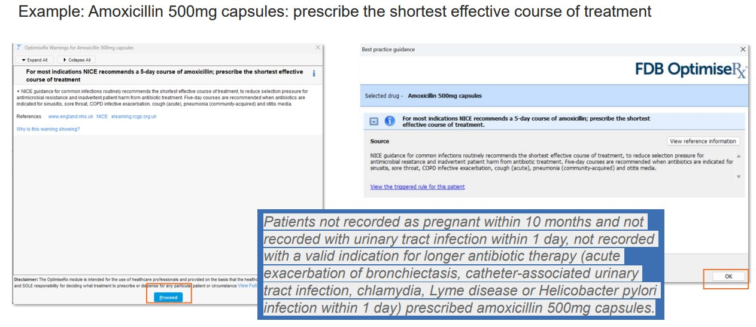

* **Headline message for Doxycycline 100mg capsules or dispersible tablets:** Where doxycycline is indicated, national guidelines recommend a five-day course for most indications (200mg on the first day, then 100mg once/day for 4 days.​
* **Details behind the headline:** NICE guidance recommends the shortest effective course of treatment, to reduce selection pressure for antimicrobial resistance and inadvertent patient harm from antibiotic treatment. Five-day courses are recommended when antibiotics are indicated for sinusitis, infective exacerbation of COPD, community acquired pneumonia, acute cough, human/animal bites.
* **The message will trigger** for all patients aged 12 years or over prescribed doxycycline 100mg unless they have certain clinical codes. These include leg ulcer, cellulitis, erysipelas, diabetic foot ulcer, acne vulgaris, non-gonococcal urethritis, epididymitis, chlamydia, pelvic inflammatory disease, Lyme disease or acute exacerbation of bronchiectasis.

**The message will trigger irrespective of the selected course length unless the patient is recorded with certain specific clinical codes. Prescribers should accurately code the indication for the antibiotic to avoid unnecessarily triggering the message when a longer duration is intended.**